

AI-POWERED CAREER GUIDANCE AND
MULTI-LEVEL ADMISSION RECOMMENDATION SYSTEM

A synopsis submitted to

Siddhant College Of Engineering
Savitribai Phule Pune University, Pune

For the partial fulfillment of Bachelor of Engineering

In

INFORMATION TECHNOLOGY
By

Suyash Nichit
Rohit sarawde
Atharva Kurlekar
Darshan devare

Under the Guidance of
Prof. Rashmi kulkarni

Department of Information Technology



Savitribai Phule Pune University
Pune Year 2024-2025

Synopsis Details



Name of College:
Siddhant College of Engineering, SPPU, Pune

Name of the Course:
Final Year (B.E) INFORMATION TECHNOLOGY

Name of Students:
Suyash Nichit
Rohit sarawde
Atharva Kurlekar
Darshan devare

Name of Guide:
Prof. Rashmi kulkarni

Proposed Title of Project:

AI-POWERED CAREER GUIDANCE
Abstract

The AI-Powered Career Guidance and Admission Recommendation System is an intelligent web-based platform developed to assist students in selecting suitable career paths and educational institutions based on their interests, skills, academic performance, and reservation category.
The system combines Artificial Intelligence (Natural Language Processing) with structured admission filtering logic to provide accurate and personalized recommendations. It is designed to reduce confusion among students by offering both career suggestions and realistic college eligibility prediction in a single integrated platform.
For career recommendation, the system uses a pre-trained NLP model to analyze user inputs such as interests, skills, and academic subjects. These inputs are compared with stored career profiles using semantic similarity techniques, and the most relevant career options are recommended.
For admission guidance, the system simulates Maharashtra CAP-style admission logic by incorporating:
- Category-wise cutoff filtering (OPEN, OBC, SC, ST, EWS)
- Branch-wise percentile comparison
- Tier-based college classification (Tier 1 to Tier 4)
- Seat availability tracking
- Placement and institutional ranking parameters
The platform supports multiple academic levels, making it comprehensive and scalable:
• After 10th: 11th Science/Commerce/Arts admission and Diploma (Polytechnic) guidance
• After 12th: Engineering and degree program eligibility prediction
• After Diploma: Direct Second Year Engineering admission support
• Post Graduation: MBA, M.Tech, and MCA admission filtering
The system is developed using:
- Frontend: HTML, CSS, JavaScript
- Backend: Python (Flask)
- Database: MySQL
- AI Model: Sentence Transformers (BERT-based semantic matching)
By integrating AI-based recommendation with real admission data, the system provides a structured, data-driven, and user-friendly solution for career and academic planning.

- Introduction
Choosing the right career path and educational institution is one of the most critical decisions in a student’s academic journey. This decision directly impacts professional growth, financial stability, and long-term career satisfaction. However, many students face confusion due to lack of structured guidance, insufficient awareness of career options, and limited understanding of real admission processes.
In traditional systems, students rely on manual counseling, peer suggestions, coaching institutes, or incomplete online resources. These methods often fail to provide personalized recommendations and do not consider important factors such as interests, skills, reservation category, cutoff trends, institutional tier, and placement statistics.


Traditi onal systems typically:
- Provide generalized advice instead of personalized recommendations
- Focus only on marks, ignoring interests and skills
- Do not include category-wise cutoff analysis (OPEN/OBC/SC/ST/EWS)
- Do not simulate real CAP-style admission processes
- Lack integration of Artificial Intelligence
As a result, students often make decisions without complete clarity or realistic expectations.
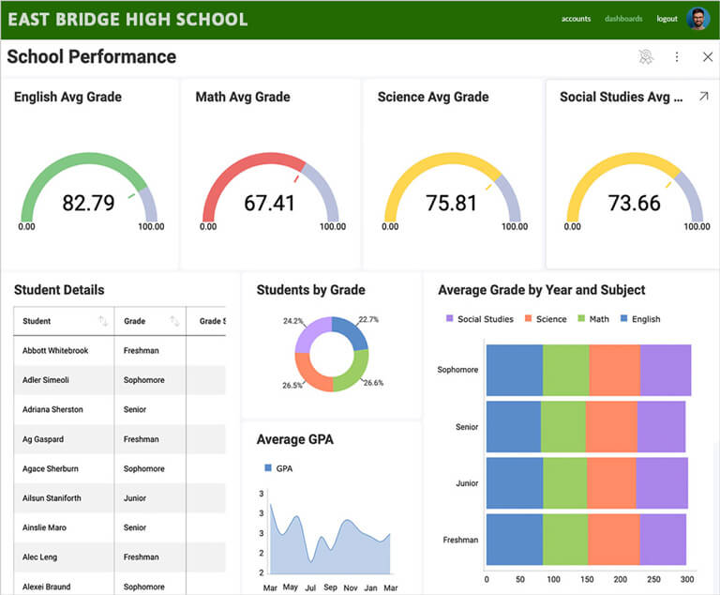
To overcome these limitations, there is a need for an intelligent, data-driven system that:
- Analyzes student interests and skills
- Uses Artificial Intelligence for career matching
- Filters colleges based on real cutoff data
- Supports multiple academic levels (10th, 12th, Diploma, Graduation)
- Provides structured and ranked recommendations
The proposed AI-Powered Career Guidance and Admission Recommendation System fulfills this need by integrating AI-based career recommendation with rule-based admission filtering. The system not only suggests suitable career paths but also predicts eligible colleges using realistic category-wise cutoff logic and tier-based ranking mechanisms.
This integration ensures that students receive personalized, accurate, and practical guidance for their academic and professional planning.

Literature Survey

Career guidance systems have evolved over time from manual counseling methods to basic online recommendation platforms. Traditional career counseling systems are primarily questionnaire-based and rely on predefined rules or human experts. These systems provide generalized advice and do not adapt dynamically to individual student profiles.
Several existing online career guidance platforms offer basic suggestions based on marks or selected interests. However, most of them have significant limitations:
• Lack of real cutoff-based college filtering
• Absence of category-wise admission analysis (OPEN, OBC, SC, ST, EWS)
• No simulation of CAP-style admission process
• Limited personalization
• No integration of Artificial Intelligence for semantic understanding
• No support for multiple academic levels (10th, 12th, Diploma, PG)
Research in the fields of Natural Language Processing (NLP) and Recommendation Systems has shown that semantic similarity models significantly improve personalization accuracy. Transformer-based models such as BERT (Bidirectional Encoder Representations from Transformers) are capable of understanding contextual meaning in text rather than relying only on keyword matching.
Recent studies indicate that:
- Semantic embedding techniques improve recommendation relevance.
- Hybrid systems combining rule-based logic and machine learning produce better accuracy than standalone approaches.
- AI-driven systems enhance decision-making in education technology platforms.
Most existing systems either focus only on career recommendation or only on college prediction. Very few systems integrate both into a single unified platform.

📌 Gap Identified in Existing Systems
From the literature review, the following gaps were identified:
- Lack of integration between career guidance and admission eligibility prediction.
- No realistic category-wise cutoff filtering.
- No tier-based ranking mechanism.
- No structured relational database for multi-level educational support.
- Limited use of AI-based semantic matching in academic planning systems.

- Problem Statement

In today’s competitive academic environment, students face several challenges while selecting the right career path and educational institution. The decision-making process is complex and requires understanding of personal interests, academic performance, entrance exam scores, reservation category, and institutional quality.
However, most students lack structured and data-driven guidance. They often depend on manual counseling, peer advice, or incomplete online information, which may lead to confusion and incorrect decisions.
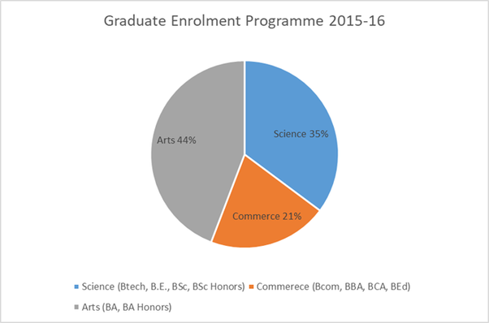

The major problems include:
Lack of personalized career guidance
Most systems do not analyze individual interests, skills, and academic strengths deeply.
Confusion between multiple academic streams
Students struggle to choose between Science, Commerce, Arts, Diploma, Engineering, and other professional courses.
Difficulty understanding cutoff trends
Category-wise percentile cutoffs (OPEN, OBC, SC, ST, EWS) are complex and difficult to interpret.
No centralized platform for career + college prediction
Students must use separate platforms for career suggestions and college eligibility checking.
No simulation of CAP-style admission process
Traditional systems do not simulate realistic admission filtering, tier ranking, or seat tracking.

There is a strong need for a system that:
- Analyzes student inputs intelligently
- Integrates AI-based career recommendation
- Filters colleges using real cutoff data
- Applies category-wise logic
- Provides structured and realistic recommendations
The proposed AI-Powered Career Guidance and Admission Recommendation System addresses these issues by combining Artificial Intelligence with rule-based admission filtering, ensuring accurate and practical guidance for students.

- Objectives

The primary objective of this project is to design and develop an intelligent, data-driven platform that provides structured career guidance and realistic admission recommendations. The system integrates Artificial Intelligence techniques with rule-based filtering logic to improve accuracy and personalization.

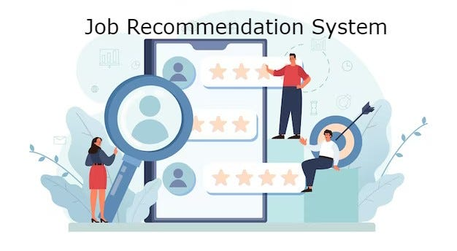

The main objectives of the project are:

• To develop an AI-based career recommendation engine
The system should analyze student interests, skills, and academic subjects using NLP-based semantic matching to recommend suitable career paths.
• To predict eligible colleges based on CET percentile and category
The system must filter colleges using branch-wise and category-wise cutoff data (OPEN, OBC, SC, ST, EWS).
• To simulate real-world CAP admission logic
The platform should implement percentile comparison, cutoff proximity analysis, and structured admission filtering similar to Maharashtra CAP.

• To provide guidance at multiple academic stages
The system should support:
- After 10th (11th admission & Diploma)
- After 12th (Engineering & Degree programs)
- After Diploma (Direct Second Year)
- Post Graduation (MBA, M.Tech, MCA)
• To rank colleges using intelligent scoring techniques
Colleges should be ranked based on:
- Tier classification
- Placement percentage
- Cutoff proximity
- Institutional quality
• To design a normalized relational database structure
The system must maintain structured data using a MySQL relational database with proper normalization and foreign key constraints.

Scope of the Project
The proposed AI-Powered Career Guidance and Admission Recommendation System is designed to provide structured academic and career guidance across multiple educational stages. The system integrates career recommendation and admission prediction within a single platform, ensuring comprehensive support for students.
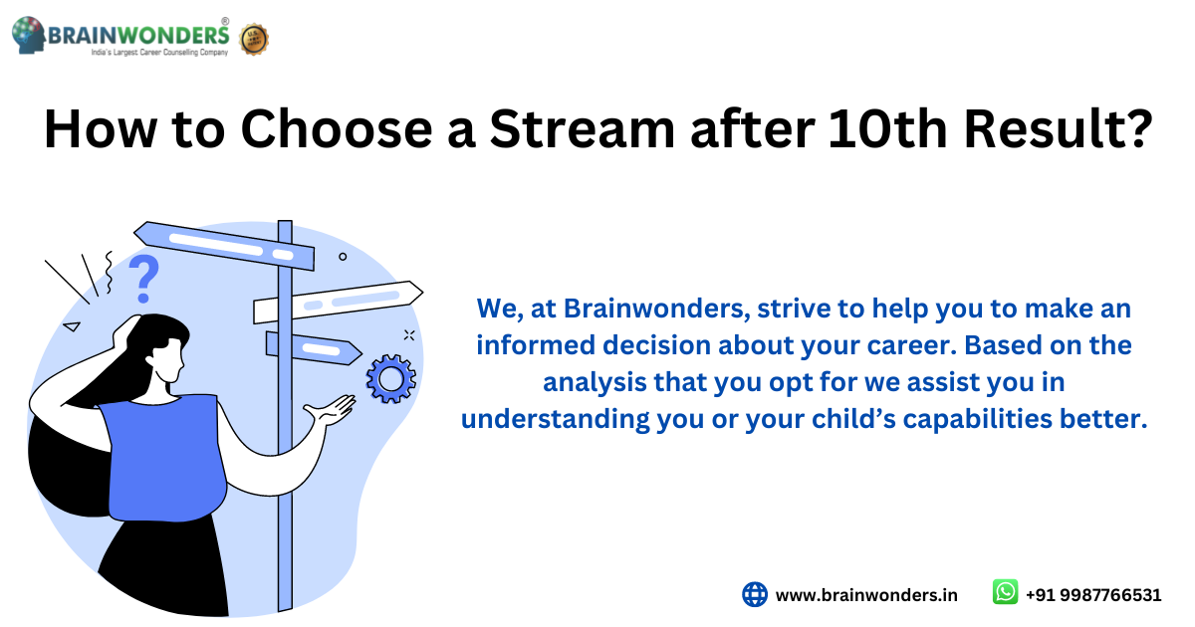

After 10th
The system provides guidance for:
- 11th admission in Science, Commerce, and Arts streams
- Diploma (Polytechnic) admission based on 10th percentage
It helps students choose between academic and technical pathways at an early stage.

🎓 After 12th
The system supports:
- Engineering (B.Tech) admission prediction
- Medical stream guidance
- Arts & Commerce degree programs
It filters colleges based on entrance exam percentile and category-wise cutoff logic.

🎓 After Diploma
The platform assists Diploma students in:
- Direct Second Year Engineering admission
It simulates lateral entry eligibility and branch-based filtering.

🎓 After Graduation
The system provides Post-Graduation guidance for:
- MBA
- M.Tech
- MCA
It applies relevant exam-based filtering (CET-PG, GATE, MCA-CET).

🌍 Geographical Scope
Currently, the system supports Maharashtra-based admission logic, including CAP-style cutoff filtering and category-wise reservation analysis. However, the architecture is scalable and can be extended to support other states by updating the database with region-specific admission rules and cutoff data.

Methodology

The proposed system follows a Hybrid Recommendation Approach, combining rule-based admission filtering with Artificial Intelligence-based semantic matching. This ensures both realistic admission prediction and personalized career recommendation.
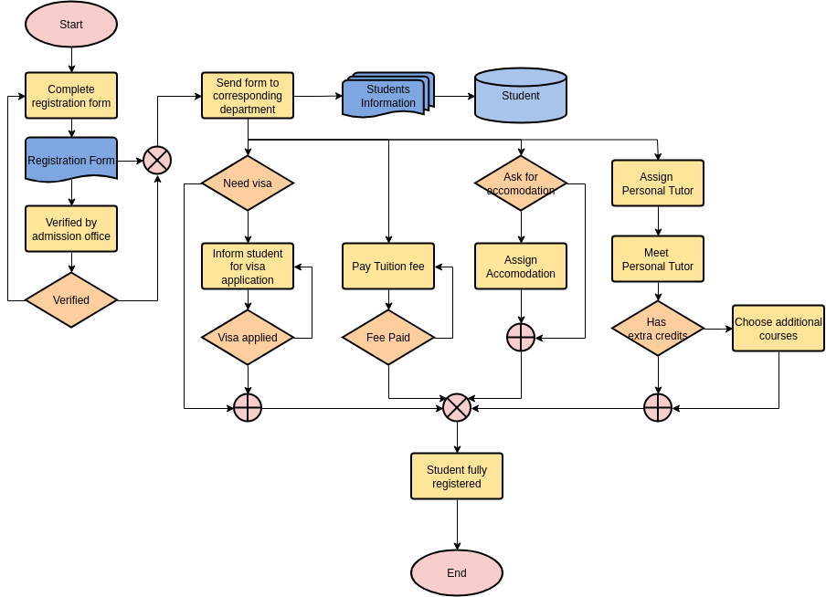
This module is used for predicting eligible colleges based on structured admission logic. It simulates real-world CAP-style admission systems by applying predefined filtering rules.

Filters Applied:
• CET Percentile – Compares student percentile with branch-wise cutoff.
• Category (OPEN/OBC/SC/ST/EWS) – Applies category-specific cutoff values.
• Branch Selection – Filters colleges based on chosen academic branch.
• Tier Ranking – Prioritizes Tier 1 to Tier 4 institutions.
• Seat Availability – Checks available seats before listing recommendations.
The system retrieves data from a structured MySQL database and returns only those colleges where the student meets eligibility criteria.
2. Semantic Matching (AI-Based Career Recommendation)
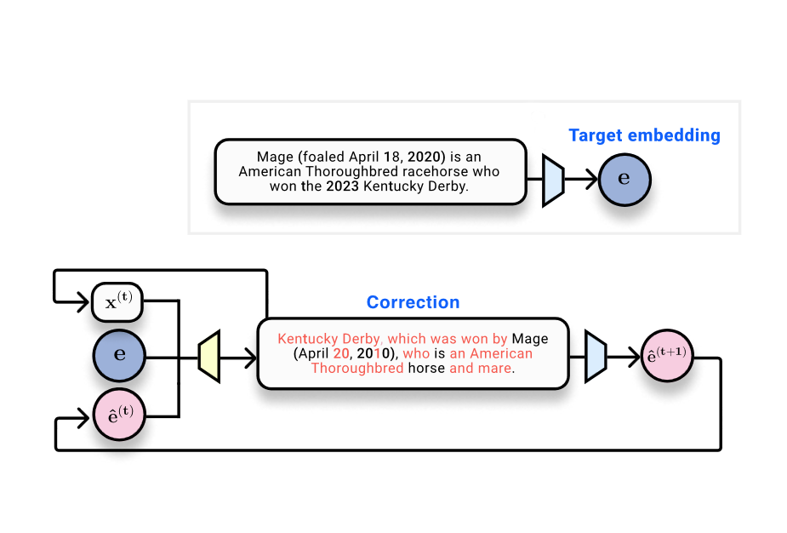
4
This module is responsible for personalized career recommendation using Natural Language Processing (NLP).

Steps Involved:
- Convert user interests, skills, and subjects into structured text input.
- Convert stored career descriptions into numerical embeddings.
- Use a BERT-based Sentence Transformer model to generate embeddings.
- Compute cosine similarity between user profile and career embeddings.
- Rank careers based on similarity score and return top matches.
This approach ensures that the system understands contextual meaning rather than relying only on keyword matching.

🔹 Hybrid Approach Advantage
By combining:
- Rule-based structured filtering (for admission prediction)
- Machine learning-based semantic similarity (for career matching)
the system provides accurate, intelligent, and realistic recommendations.

System Architecture

The system follows a multi-layered architecture that separates presentation, application logic, AI processing, and database management. This layered design ensures scalability, maintainability, and efficient data processing.
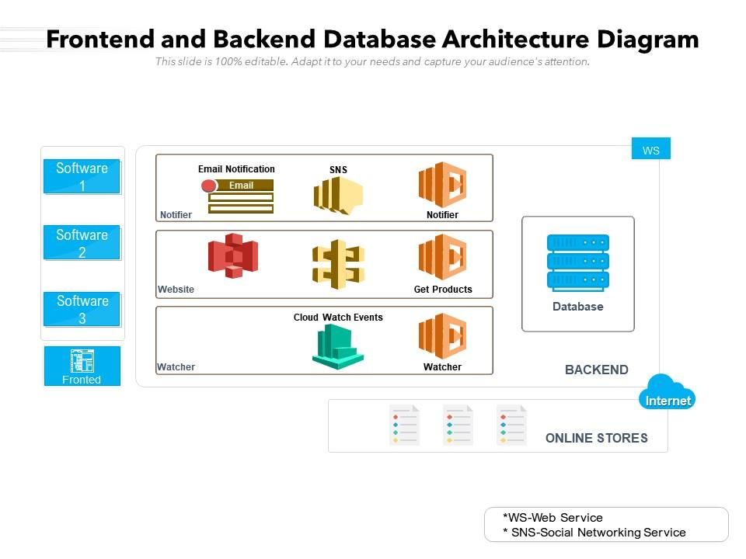
The architecture consists of four major layers:

🔹 1. Frontend Layer
Technologies Used:
- HTML
- CSS
- JavaScript
The frontend layer is responsible for user interaction and interface design. It collects user inputs such as:
- Interests
- Skills
- Subjects
- CET percentile
- Category
- Branch preference
The frontend sends this data to the backend through REST API calls and displays the recommended careers and eligible colleges in a structured format.

🔹 2. Backend Layer
Technology Used:
- Python Flask (REST API)
The backend layer handles:
- Processing user requests
- Applying rule-based filtering
- Interacting with the database
- Returning structured responses
Flask APIs manage endpoints such as:
- Career recommendation
- College eligibility prediction
This layer acts as a bridge between frontend and database/AI modules.

🔹 3. AI Layer
Technology Used:
- Sentence Transformers
- BERT (all-MiniLM-L6-v2 model)
The AI layer performs semantic matching for career recommendation. It:
- Converts text inputs into embeddings
- Computes cosine similarity
- Ranks career options based on similarity score
This ensures contextual understanding rather than simple keyword comparison.

🔹 4. Database Layer
Technology Used:
- MySQL (Relational Database Model)
The database stores:
- Career data
- College details
- Branch information
- University details
- Category-wise cutoff values
- Seat availability
Foreign key constraints and normalization techniques are used to maintain data consistency and integrity.

🔹 Data Flow in the System
- User enters data in frontend.
Frontend sends request to Flask API.
Backend applies:
- Rule-based filtering (admission)
- AI semantic matching (career)
- Backend retrieves data from MySQL.
- Results are ranked and returned to frontend.
- Frontend displays structured recommendations.

Database Design

The system uses a MySQL relational database designed using normalization principles to ensure data consistency, scalability, and efficient querying. The database structure supports multi-level academic guidance, category-wise filtering, and seat tracking.
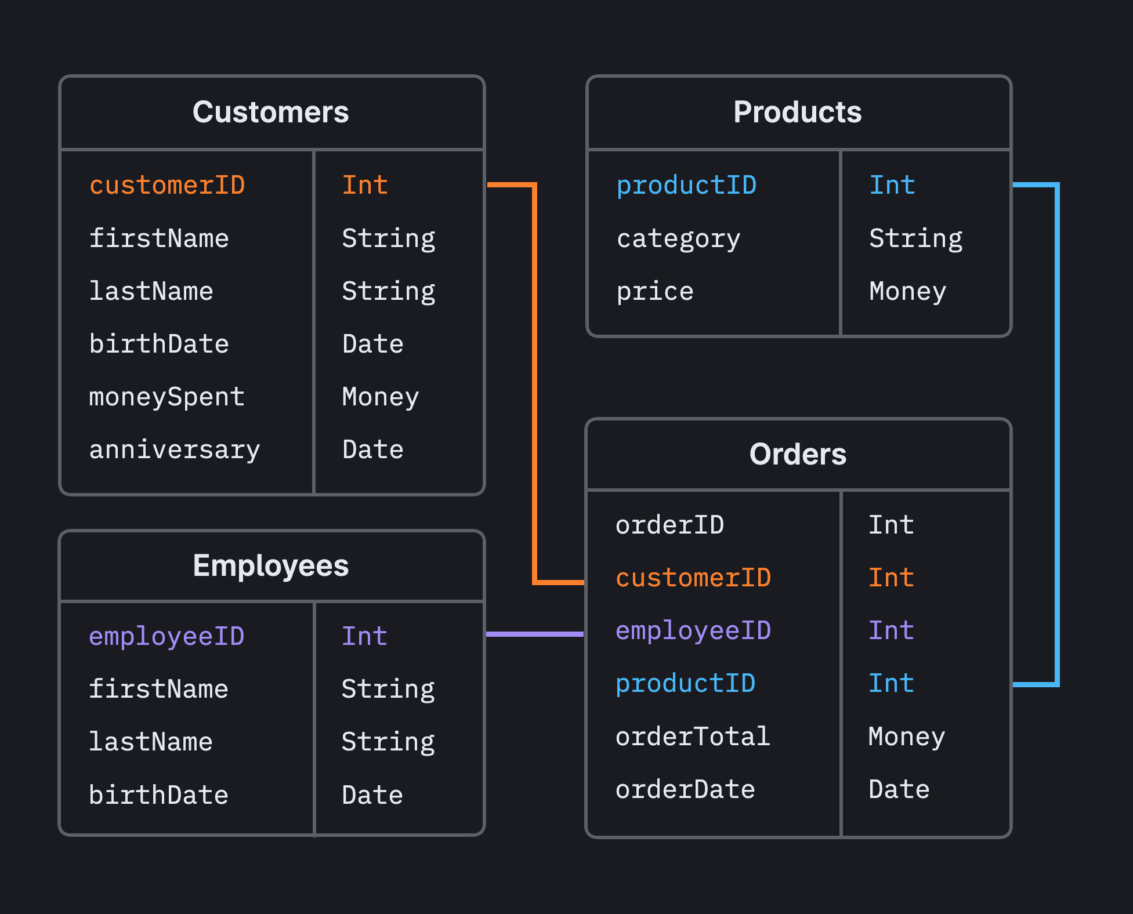
The core tables in the database include:

🔹 1. users
Stores student information such as:
- Name
- Email
- Academic details
- CET percentile
- Category

🔹 2. careers
Contains career-related data including:
- Career title
- Description
- Required skills
- Required subjects
- Minimum eligibility criteria
- Average salary

🔹 3. colleges
Stores institutional information:
- College name
- Branch
- Exam type
- Cutoff percentile
- Tier classification
- Placement percentage
- NAAC grade

🔹 4. branches
Maintains academic branch information such as:
- Computer Engineering
- Mechanical Engineering
- Civil Engineering
- MBA
- M.Tech
- Diploma branches

🔹 5. universities
Stores university-level data linked to colleges through foreign keys.

🔹 6. college_branch_cutoffs
Stores:
- Category-wise cutoff percentiles
- Branch-wise filtering data
- Total seats
- Available seats

🔹 7. college_exam_cutoffs
Stores exam-specific cutoff information such as:
- CET
- GATE
- MCA-CET
- SSC

⚙ Key Database Features
• Foreign Key Constraints
Ensures referential integrity between tables (e.g., colleges linked to universities and branches).
• Normalized Structure
Reduces redundancy and improves query performance.
• Category-wise Cutoff Storage
Enables CAP-style filtering for OPEN, OBC, SC, ST, and EWS categories.
• Seat Tracking Mechanism
Allows simulation of real-world admission seat allocation.

🔹 Database Design Advantage
The structured relational design ensures:
- Efficient filtering
- Accurate percentile comparison
- Scalable expansion to other states
- Clean integration with backend APIs

Module Description
The AI-Powered Career Guidance and Admission Recommendation System is divided into multiple functional modules. Each module performs a specific task to ensure accurate, intelligent, and structured recommendations.

This module provides personalized career guidance using Artificial Intelligence.

Key Functions:
• Accepts user inputs such as interests, skills, and academic subjects
• Converts input text into embeddings using BERT-based model
• Uses semantic similarity (cosine similarity) to match career profiles
• Returns top 5 most relevant career options
This ensures intelligent career matching rather than simple keyword-based suggestions.
- College Eligibility Module
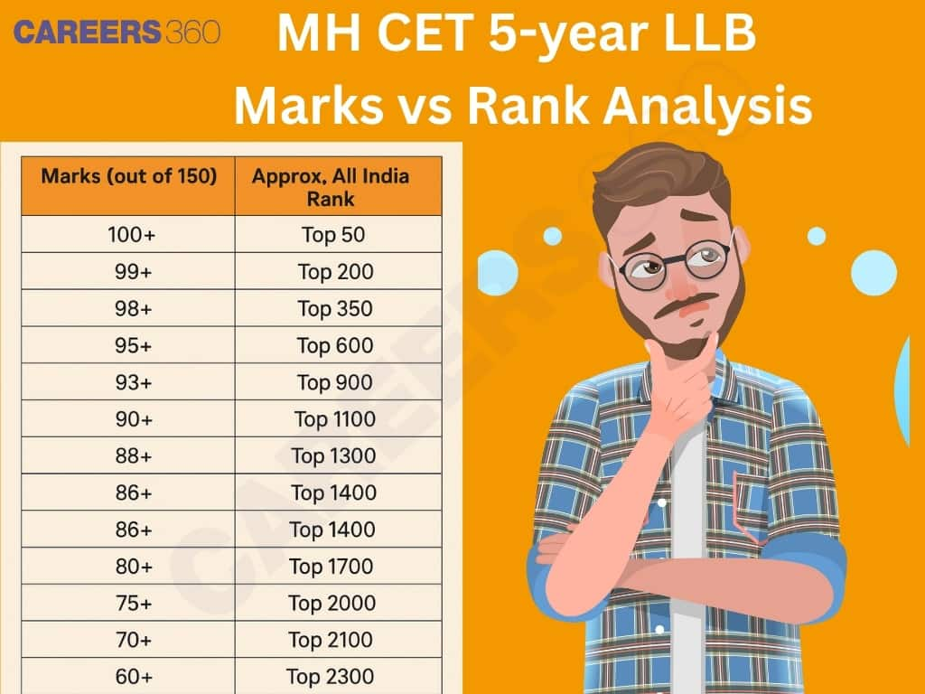
This module predicts eligible colleges based on structured admission logic.

Key Functions:
• Accepts CET percentile and category
• Applies category-wise cutoff comparison
• Filters colleges using CAP-style logic
• Checks branch eligibility
• Returns list of eligible colleges
This module simulates real-world admission filtering.
- Ranking Module
After filtering eligible colleges, the system ranks them using intelligent scoring techniques.

Ranking Factors:
• Tier classification (Tier 1–Tier 4)
• Placement percentage
• Cutoff proximity (difference between student percentile and cutoff)
• NAAC grade
This ensures meaningful prioritization instead of random listing.
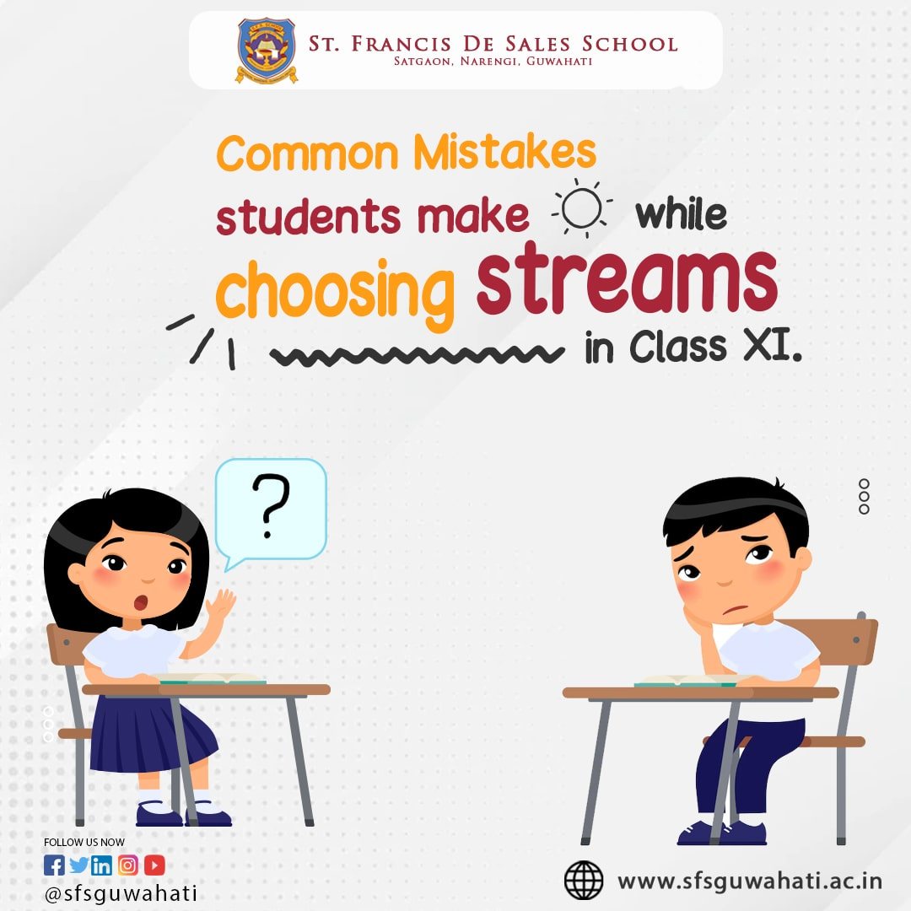
This module supports guidance across multiple academic levels:
• Junior Colleges (11th Science, Commerce, Arts)
• Diploma (Polytechnic) admissions
• Engineering (UG programs)
• Post Graduation (MBA, M.Tech, MCA)
This makes the system comprehensive and adaptable to different educational stages.

Algorithms Used

The system uses a combination of Artificial Intelligence algorithms and rule-based sorting techniques to provide accurate career and college recommendations.

Purpose:
Used for comparing user profile embeddings with career description embeddings.
After converting text into numerical vectors using a BERT-based Sentence Transformer model, cosine similarity measures the similarity between two vectors.

Formula:
Cos(θ)=A⋅B∣∣A∣∣×∣∣B∣∣Cos(\theta) = \frac{A \cdot B}{||A|| \times ||B||}Cos(θ)=∣∣A∣∣×∣∣B∣∣A⋅B​
Where:
- A = User profile embedding
- B = Career description embedding

Interpretation:
- Value close to 1 → Highly similar
- Value close to 0 → Less similar
This ensures context-based career recommendation rather than simple keyword matching.

- Tier-Based Sorting Algorithm
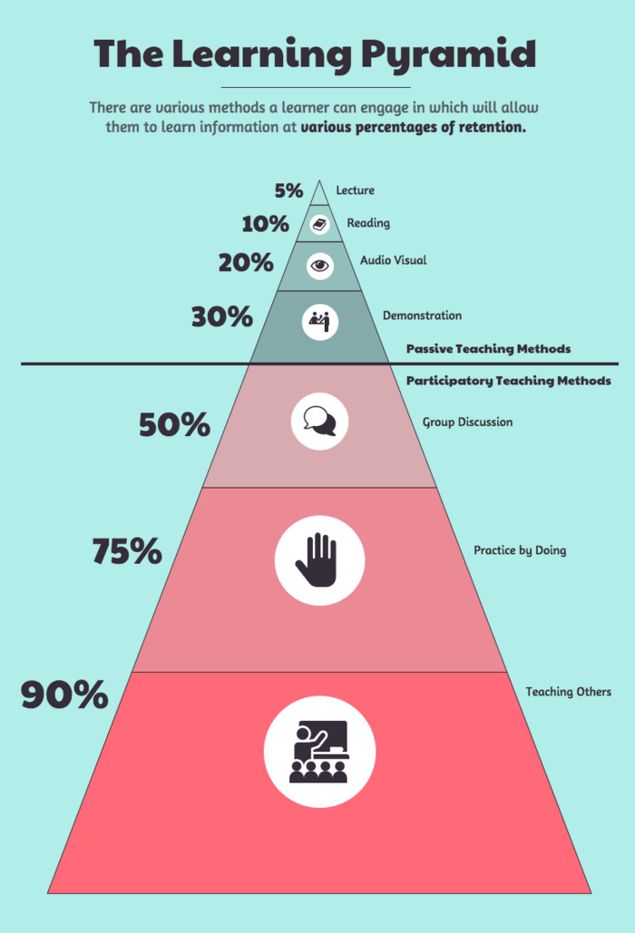
Purpose:
Used to prioritize colleges based on institutional classification.

Tier Priority:
- Tier 1 → Highest priority
- Tier 2 → Medium priority
- Tier 3 → Lower priority
- Tier 4 → Basic option
During ranking, Tier 1 colleges are given higher weight compared to lower tiers.

- Cutoff Proximity Formula
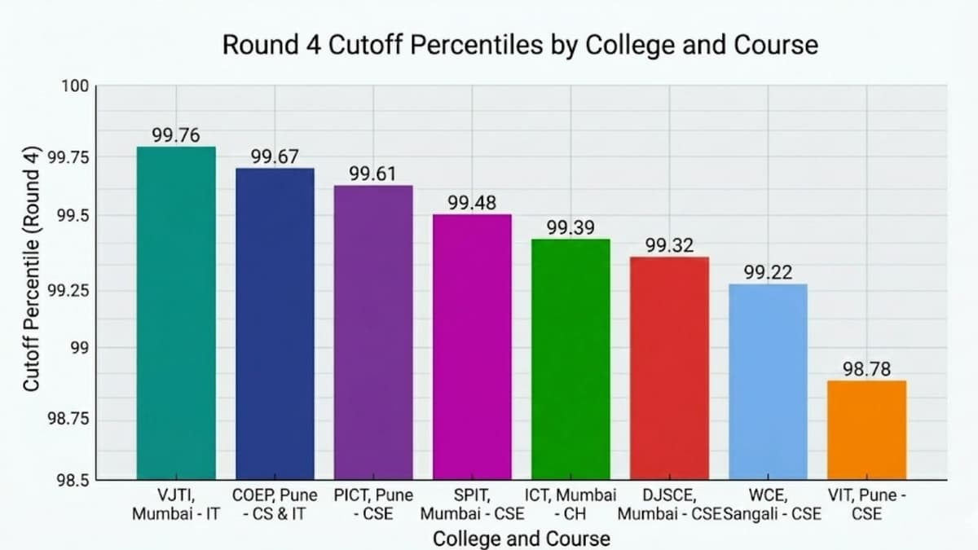
Purpose:
Used to determine how close a student’s percentile is to the college cutoff.

Formula:
Difference=Student Percentile−CutoffDifference = Student\ Percentile - CutoffDifference=Student Percentile−Cutoff

Interpretation:
- Smaller positive difference → Higher ranking
- Large difference → Lower ranking
- Negative difference → Not eligible
This ensures realistic and accurate college prioritization.

10. Advantages of the Proposed System
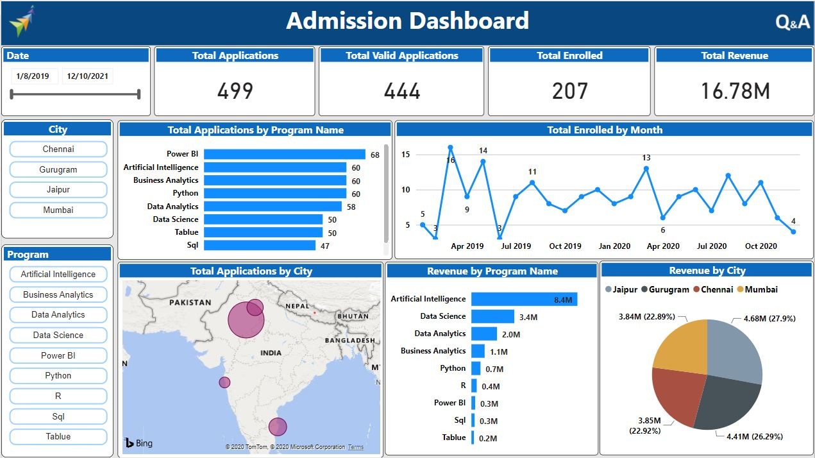
The proposed AI-Powered Career Guidance and Admission Recommendation System offers several key advantages:
• Personalized Career Guidance
Uses AI-based semantic matching to recommend careers based on individual interests, skills, and subjects.
• Real CAP-Style Simulation
Implements percentile comparison, category-wise filtering, and seat tracking similar to real admission systems.
• Category-Wise Filtering
Supports OPEN, OBC, SC, ST, and EWS category-based cutoff analysis.
• Multi-Level Academic Support
Provides guidance after 10th, 12th, Diploma, and Graduation.
• Intelligent Ranking System
Ranks colleges using tier classification, placement percentage, and cutoff proximity.
• Scalable Architecture
Designed using modular layers (Frontend, Backend, AI, Database), allowing easy expansion to other states or programs.

11. Limitations
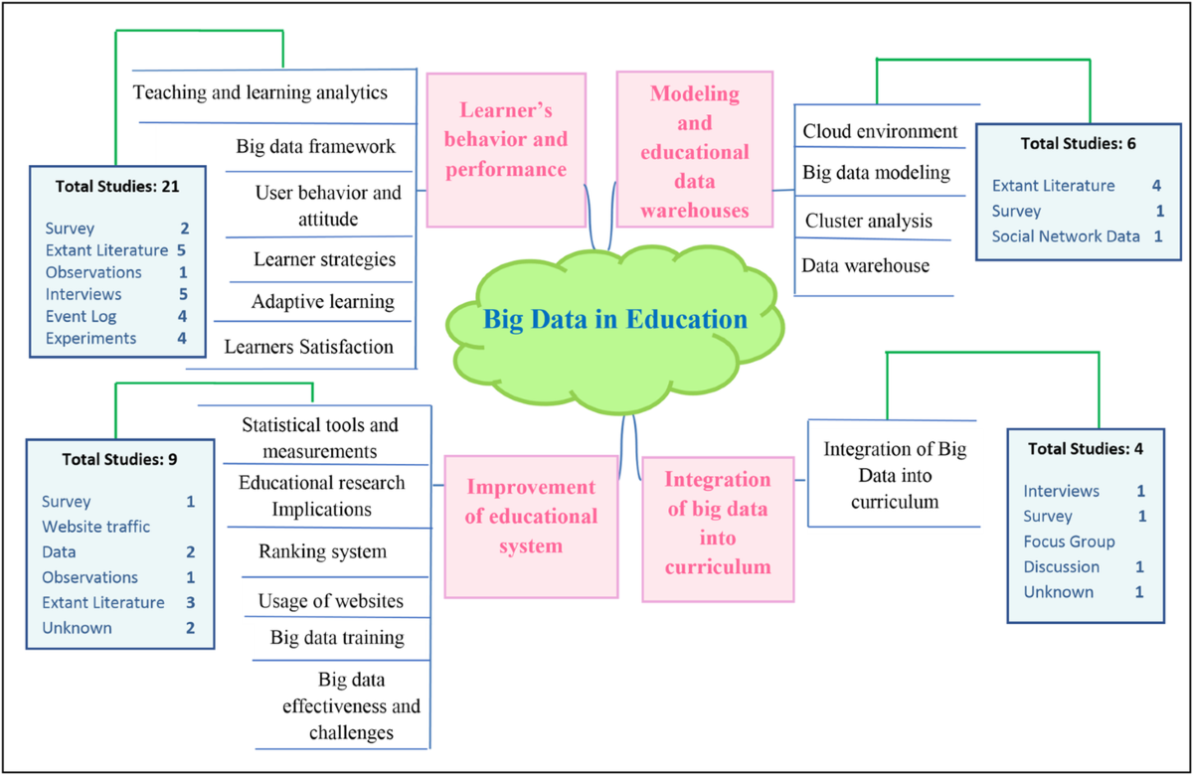
Although the system provides intelligent and structured recommendations, it has certain limitations:
• Currently limited to Maharashtra data
The admission logic and cutoff structure are based on Maharashtra CAP rules.
• Cutoff data manually structured
The system uses manually maintained cutoff data, which may require periodic updates.
• No real-time CAP updates
The platform does not automatically fetch live admission or seat allocation updates.
• Requires internet connection for AI model
The semantic matching model requires internet access during initial loading or updates.

12. Future Scope
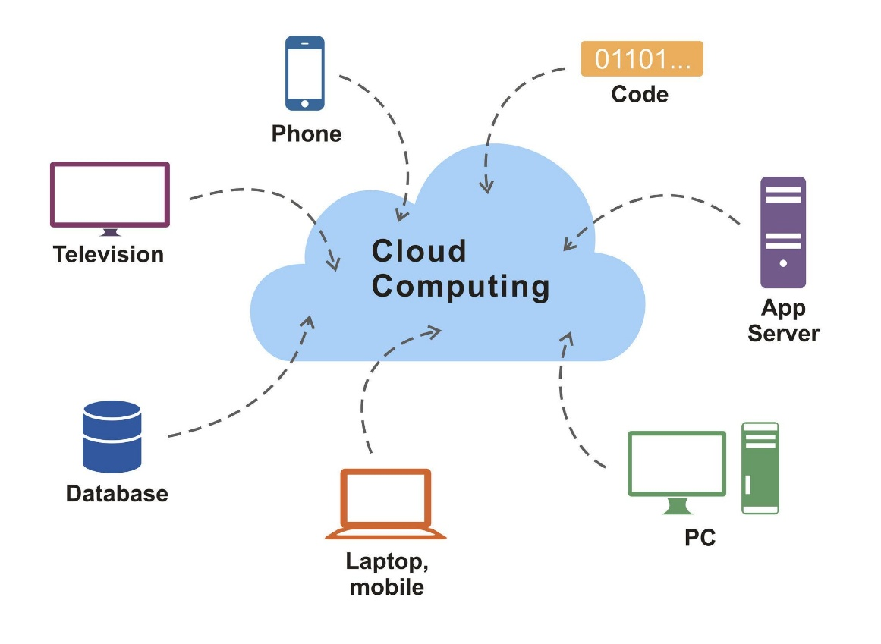
The proposed system can be further enhanced and expanded with the following improvements:
• Mobile Application Development
Developing Android and iOS applications for wider accessibility.
• Real-Time CAP Round Updates
Integration with live admission data to provide updated seat allocation and cutoff trends.
• Chatbot-Based AI Counselor
Implementing an interactive AI chatbot to provide instant career guidance.
• Multi-State Support
Expanding the system to support admission rules and cutoff data for multiple states.
• Dashboard Analytics
Adding analytical dashboards for students to track eligibility trends and performance insights.
• AI-Based Seat Prediction
Using predictive models to estimate admission probability based on historical data.
• Cloud Deployment
Hosting the system on cloud platforms for scalability, reliability, and high availability.

13. Conclusion

The AI-Powered Career Guidance and Multi-Level Admission Recommendation System provides a comprehensive and intelligent solution for students seeking structured career and college guidance. The system successfully integrates Artificial Intelligence-based semantic matching with real-world admission filtering logic to ensure accurate and realistic recommendations.
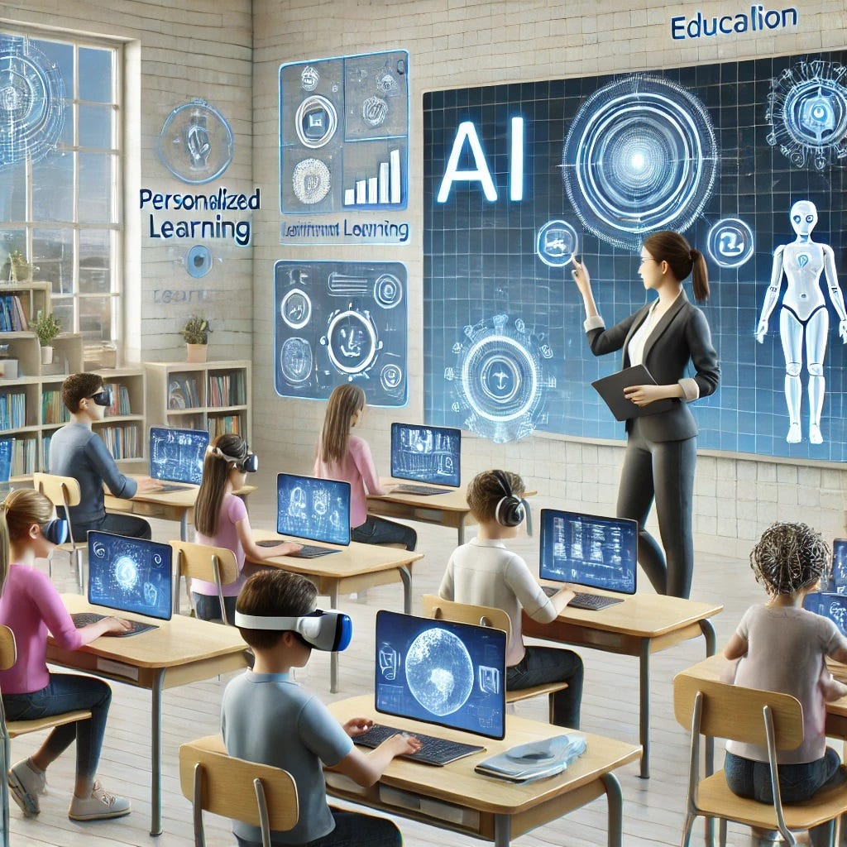
By combining personalized career suggestions with CAP-style college eligibility prediction, the platform bridges the gap between career counseling and actual admission planning. It supports multiple academic stages, making it adaptable and scalable for diverse educational pathways.
Overall, the system enhances decision-making, reduces uncertainty in academic planning, and provides a data-driven approach to career and admission guidance.

